**Name: ________________________**

**Registration: ___________________**

**Design a 3x8 Decoder using as building block the 2x4 Decoder shown below. Use the provided block diagram and skeleton file to implement the 3x8 Decoder.**

| **module Dec2x4 (y, En, w);**  **output [0:3] y;**  **input En;**  **input [1:0] w;**  **reg [0:3] y;**  **always @(En or w)**  **if (En)**  **case (w)**  **2'b00: y = 4'b1000;**  **2'b01: y = 4'b0100;**  **2'b10: y = 4'b0010;**  **2'b11: y = 4'b0001;**  **endcase**  **else**  **y = 4'b0000;**  **endmodule** |
| --- |

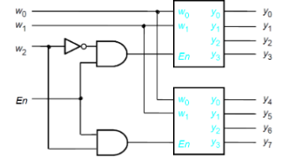

| **module Dec3x8 (y, En, w);**  **output [0:7] y;**  **input En;**  **input [2:0] w;**  **//Write your code here**  **endmodule** |
| --- |